EC2 to Workbench Connect Approach

Prerequisites:

1. Create ec2
2. Security Group with ssh,http,Mysql/arora need to added in rules

Steps:

1-Connect ec2

2-Go to root user – (sudo -i)

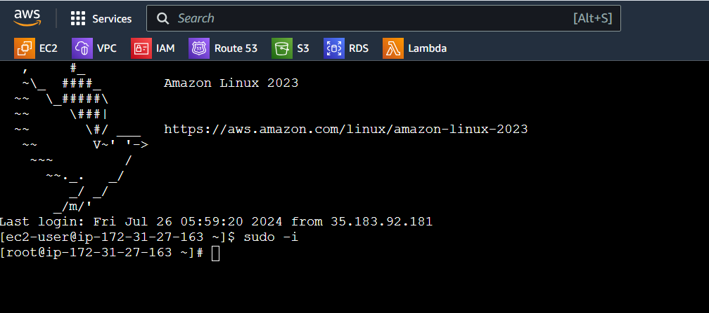

1. Update the package index :- sudo dnf update -y

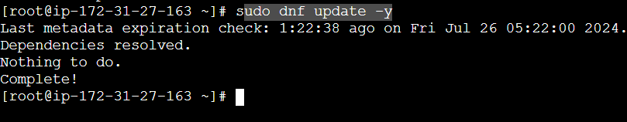

1. Download the MySQL 8.0 community release package

sudo wget https://dev.mysql.com/get/mysql80-community-release-el9-4.noarch.rpm

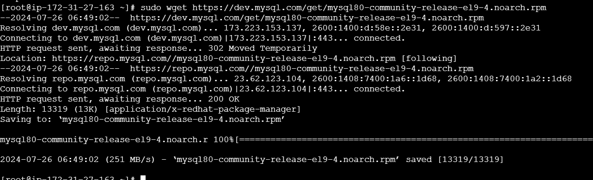

5-Install the MySQL community release package

sudo dnf install mysql80-community-release-el9-4.noarch.rpm -y

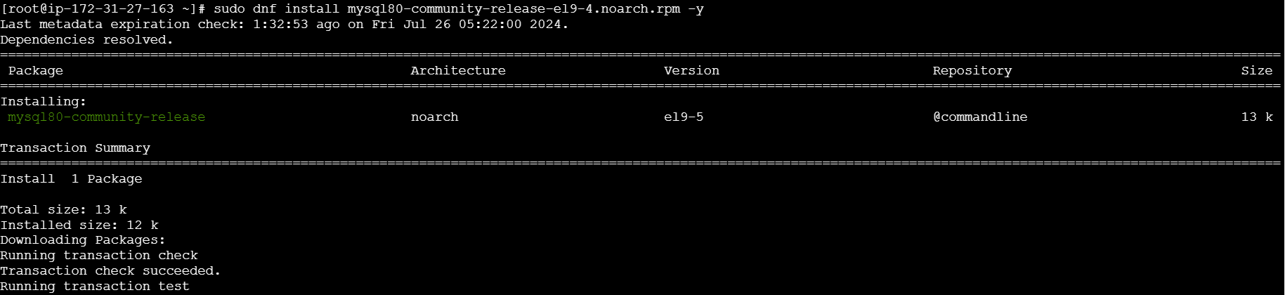

6- Install MySQL server

sudo dnf install mysql-community-server -y

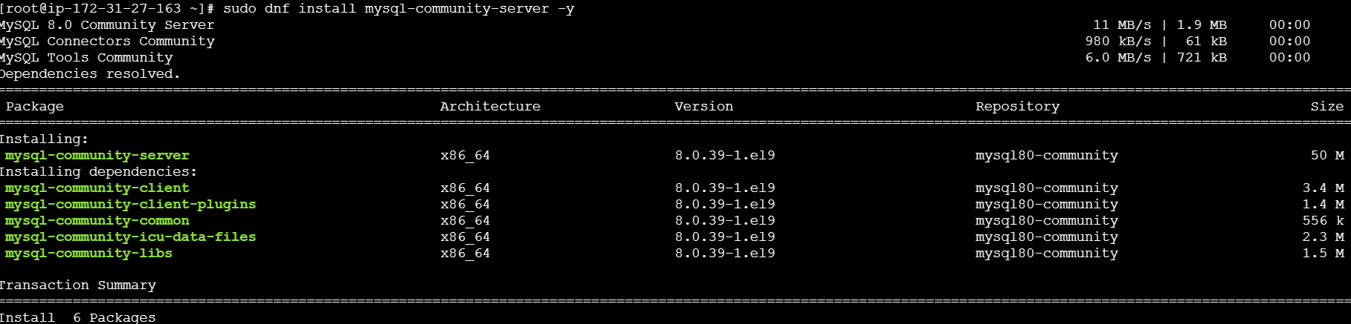

7- Verify MySQL installation

mysql -V



Use all below command to Active your Mysql server

8- Start the MySQL service

sudo systemctl start mysqld

9- Enable MySQL to start on boot

sudo systemctl enable mysqld

10- Check MySQL service status

systemctl status mysqld

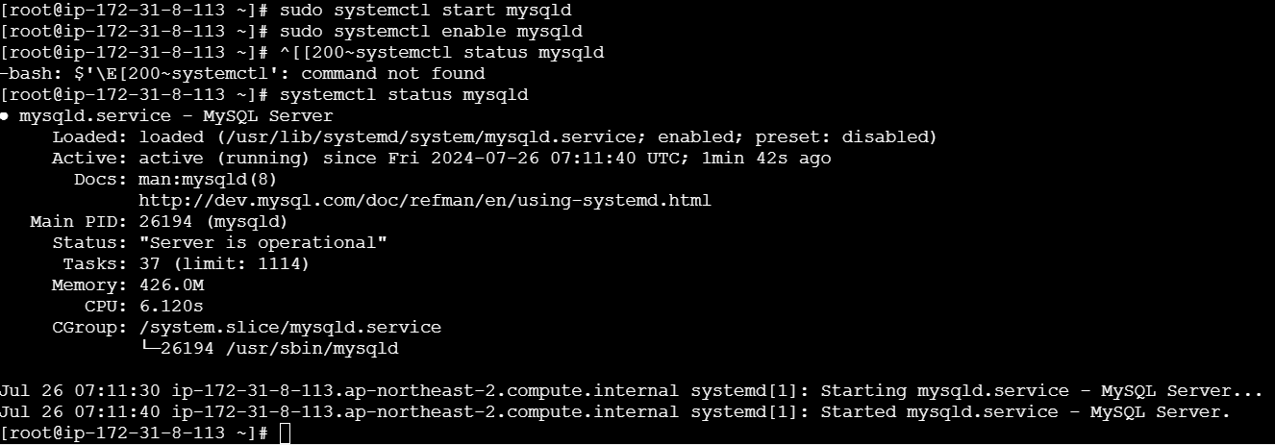

11- Get the temporary password generated for the root user

sudo grep 'temporary password' /var/log/mysqld.log



12- Note the temporary password from the output, e.g., **%uaqyK:U_8e8**

note temp passwd **duwXq1/.W!40**

13- Login with temporary password First

mysql -u root -p



14- Enter temporary password

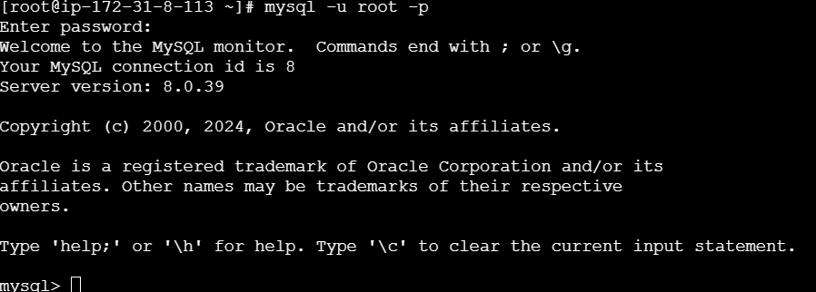

15-reset temp password

ALTER USER 'root'@'localhost' IDENTIFIED BY 'Clou&12345';

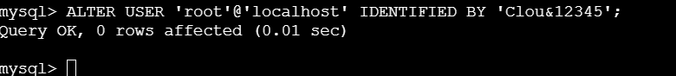

16- #create sample data base

CREATE DATABASE IF NOT EXISTS demodb;

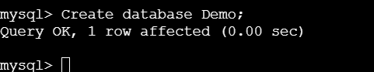

17- CREATE TABLE Demo.Friends (

PersonID int,

LastName varchar(255),

FirstName varchar(255),

Address varchar(255),

City varchar(255) );

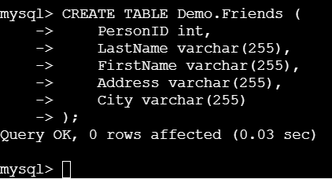

18- SHOW TABLES

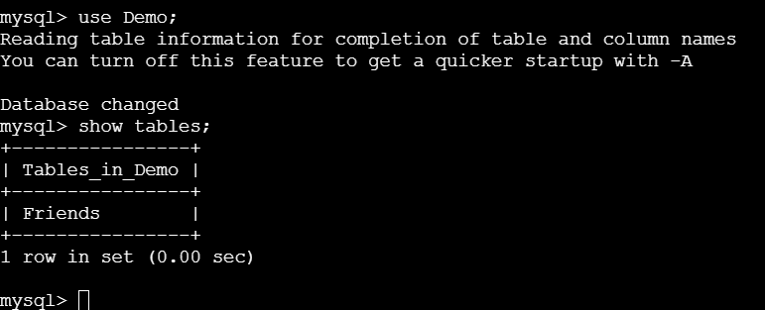

19- Insert value into table  


20- Show Tables data

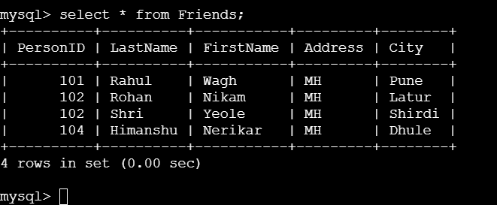

21-Open Workbench and Click on MYSQL Connections

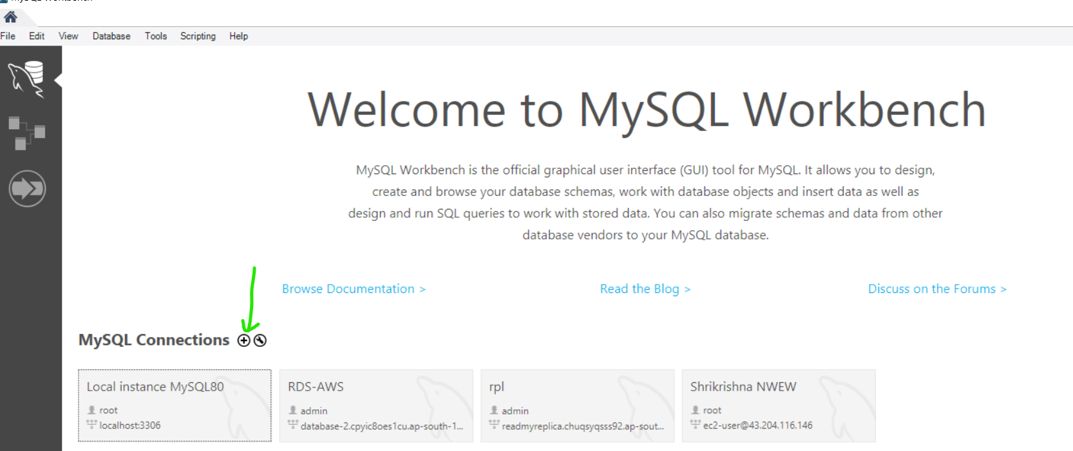

22- Select Standard TCP/IP over SSH

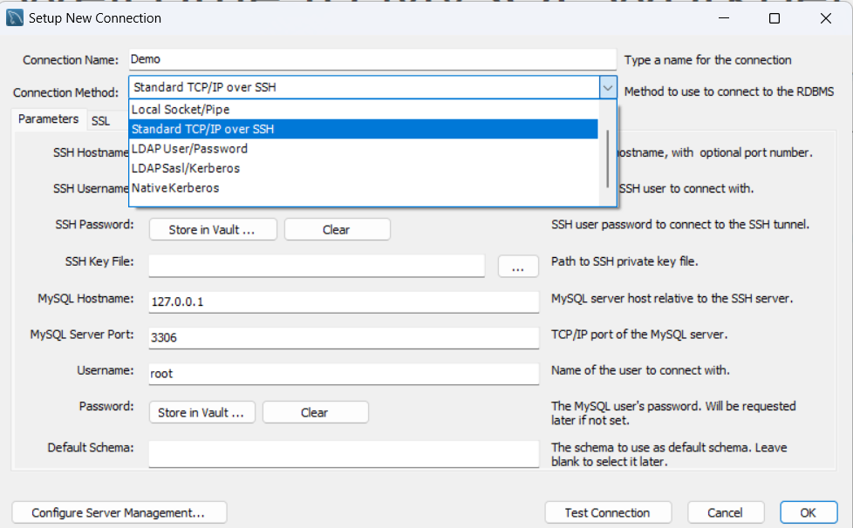

23- SSH Hostname = EC2 Public IP - 13.125.29.196

SSH Username = ec2-user

24- Select Key Pair Path which we have selected while creating instance

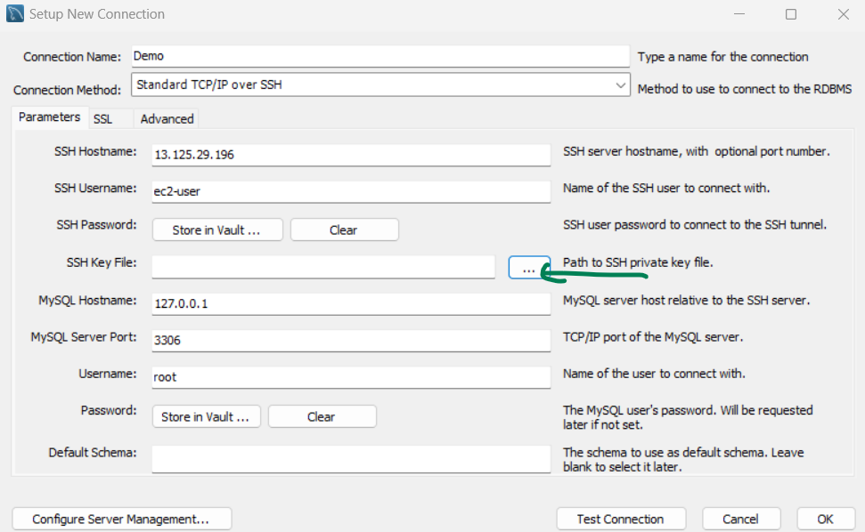

25- Give the Key path

26- Click on Store in Vault.. and insert your password which we have given while creating Mysql server(**Clou&12345**)

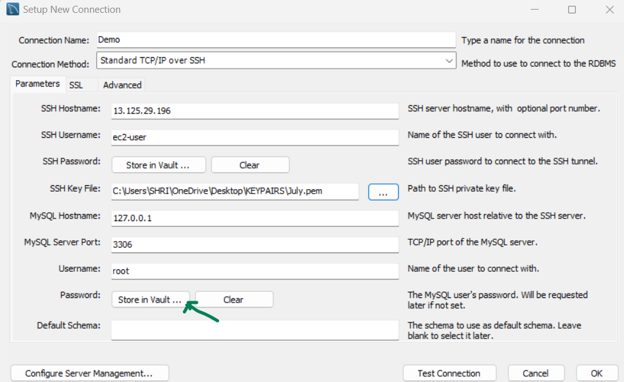

27- Click on Test Connect 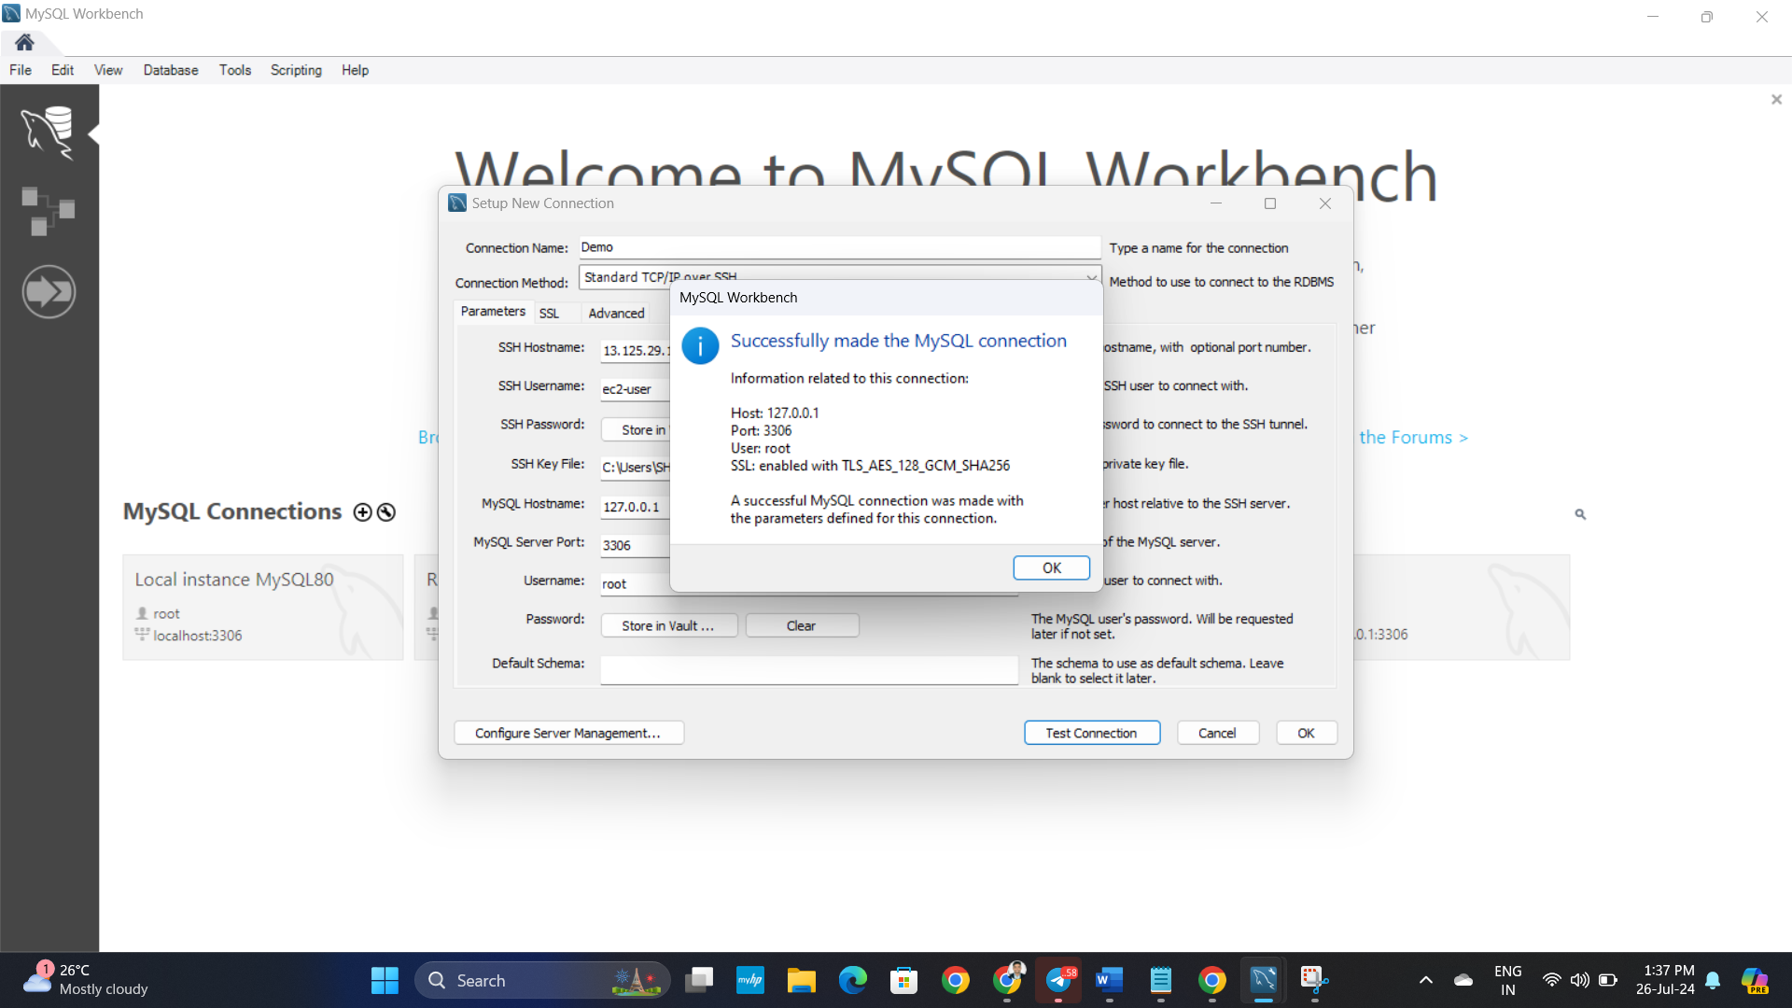

**Successfully made the MYSQL connection**

**Thank you..**